🔁 Apache Camel Circuit Breaker
In Apache Camel, a Circuit Breaker is used to prevent cascading failures when calling unstable external systems like REST APIs, databases, or microservices.
If a service keeps failing, Camel “opens the circuit” and stops calling it for some time, instead returning a fallback response.

🧠 Why Circuit Breaker?
Imagine:
File → Camel → External REST API → Database
If the REST API is down:
- Without circuit breaker → every request fails → system overload
- With circuit breaker → stops calling API temporarily → system survives

🔄 Circuit Breaker States
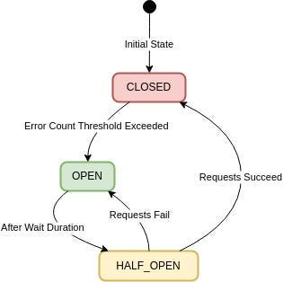
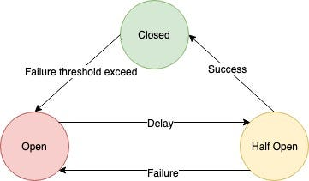
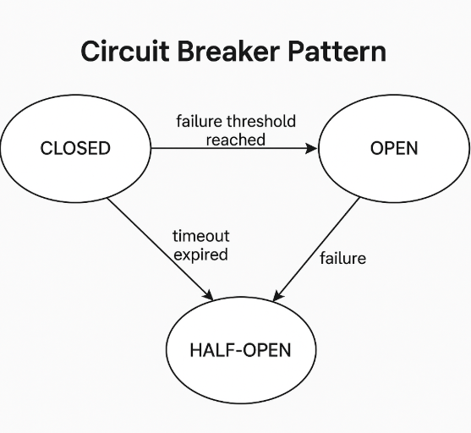
1️⃣ Closed State
- Normal operation
- Calls pass through
- Failures are counted
2️⃣ Open State
- Too many failures detected
- Calls are blocked immediately
- Fallback is triggered
3️⃣ Half-Open State
- After timeout
- Allows limited test calls
- If success → Closed
- If failure → Open again

🛠 Circuit Breaker in Apache Camel
Camel supports:
- Resilience4j (Recommended)
- MicroProfile Fault Tolerance
- Hystrix (deprecated)
We use Resilience4j.

📦 Maven Dependency
<dependency>
<groupId>org.apache.camel</groupId>
<artifactId>camel-resilience4j</artifactId>
</dependency>

✅ Simple Production Example
Scenario:
- Call external REST API
- If it fails 3 times → open circuit
- Wait 10 seconds
- Use fallback

🔹 Java DSL Example
@Component
public class CircuitBreakerRoute extends RouteBuilder {

@Override
public void configure() {

from("direct:start")
.routeId("circuit-breaker-demo")

.circuitBreaker()
.resilience4jConfiguration()
.failureRateThreshold(50)
.minimumNumberOfCalls(3)
.waitDurationInOpenState(10000)
.end()

.to("http://localhost:8081/external-service")

.onFallback()
.log("Service is down! Executing fallback")
.setBody().constant("Fallback Response")
.end();
}
}

🔎 What Happens Internally?
Property | Meaning
failureRateThreshold(50) | Open if 50% calls fail
minimumNumberOfCalls(3) | Evaluate after 3 calls
waitDurationInOpenState(10000) | Stay open for 10 seconds
onFallback() | Alternative logic

🏗 Real Microservice Flow
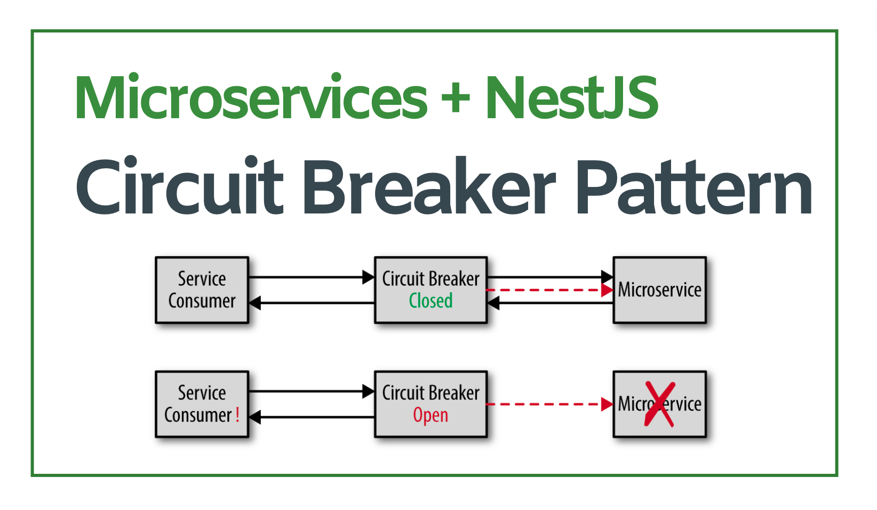
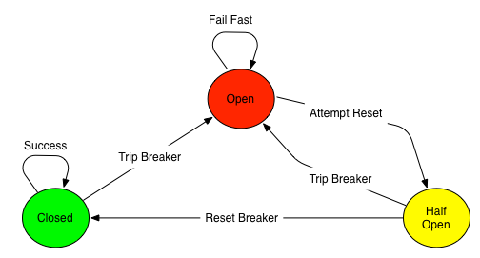
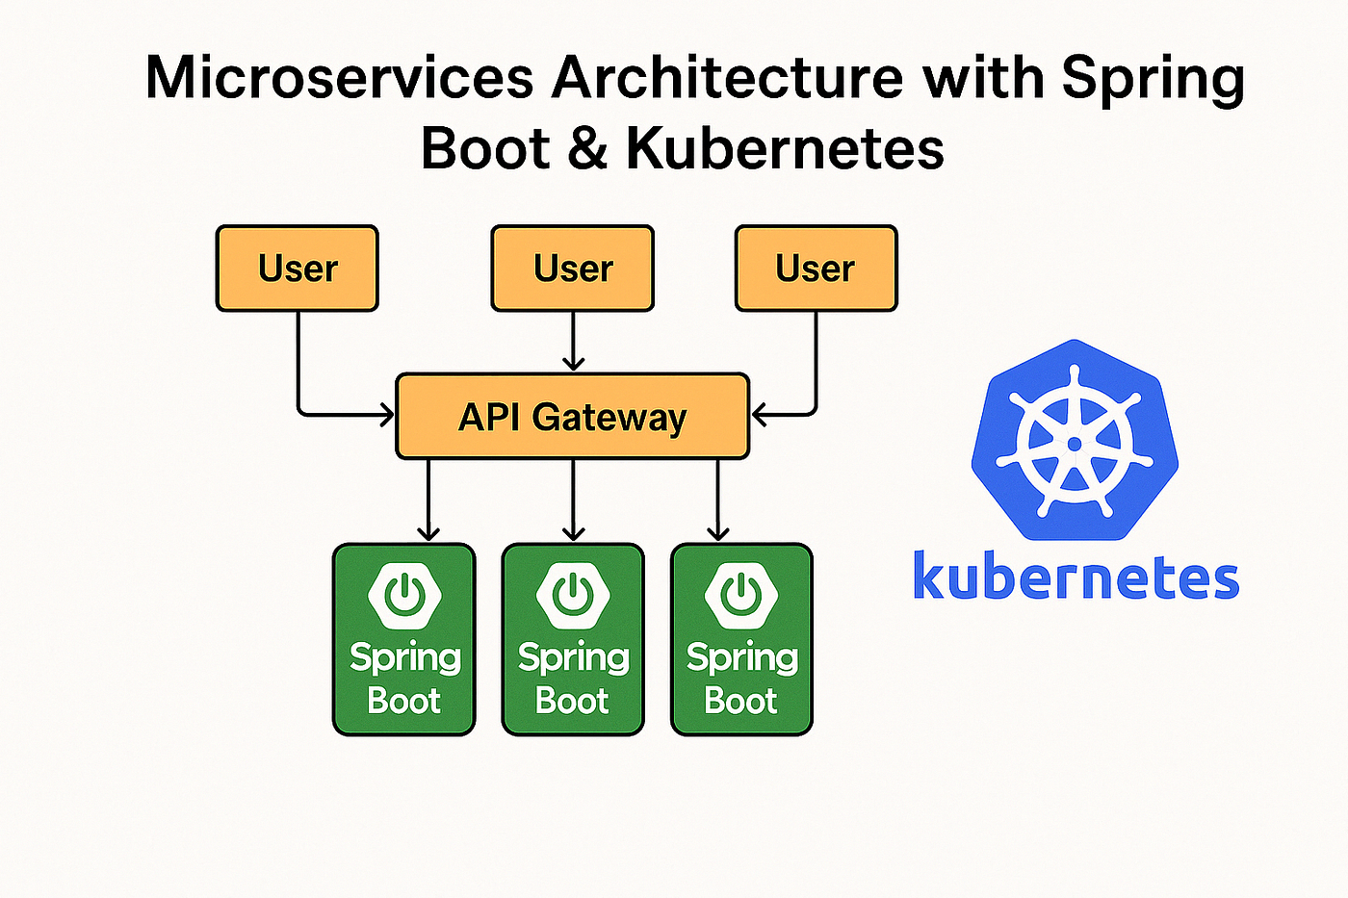
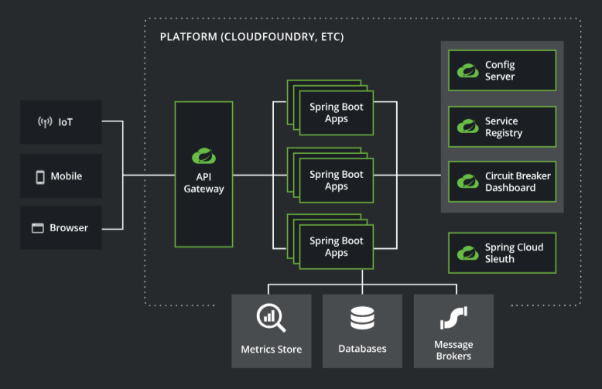
Flow:
Client → Camel → External Service
↓
Circuit Breaker
↓
Fallback Logic

🔥 Advanced Production Configuration
.resilience4jConfiguration()
.slidingWindowSize(10)
.permittedNumberOfCallsInHalfOpenState(2)
.waitDurationInOpenState(20s)
.slowCallRateThreshold(60)
.slowCallDurationThreshold(2s)
.end()
Advanced Controls:
- Sliding window metrics
- Half-open test calls
- Slow call detection
- Timeout handling

🧪 Testing Scenario
- Start external service
- Send requests → works (Closed)
- Stop service
- After threshold → Circuit opens
- Requests return fallback immediately
- After wait duration → Half-open test
- If service back → closes again

"Apache Camel Circuit Breaker prevents cascading failures by monitoring service call failures and automatically opening the circuit when failure threshold is reached. It supports Resilience4j integration and provides fallback mechanisms."

🎯 When to Use Circuit Breaker?
Use it when:
- Calling REST APIs
- Kafka consumers calling DB
- Payment gateways
- External cloud services
- Microservices communication

This is a complete Apache Camel + Resilience4j Circuit Breaker implementation that demonstrates resilience patterns for microservices. Here's the full explanation:
Architecture Overview
text
Client → http://localhost:8080/api/orders/123
↓
[Camel REST DSL] → direct:getOrder
↓
[Resilience4j Circuit Breaker]
↓
Spring Controller: localhost:8080/unstable-service
↓
Returns SUCCESS or throws Exception (50% failure rate)
Complete Flow Explanation
1. Entry Point: Camel REST DSL
text
camel.servlet.mapping.context-path: /api/*
- Exposes /api/orders/{id} endpoint
- Routes to direct:getOrder internal endpoint[camel.apache]​
2. Circuit Breaker Route (Core Logic)
java
from("direct:getOrder")
.circuitBreaker() // ← Resilience4j wrapper
.resilience4jConfiguration() // ← Configures thresholds
.failureRateThreshold(50) // 50% failures → OPEN
.slidingWindowSize(5) // Track last 5 calls
.waitDurationInOpenState(10) // 10s timeout
.end()

.log("Calling external service...")
.toD("http://localhost:8080/unstable-service?orderId=${header.id}")
.log("External service responded")

.onFallback() // ← Fallback when OPEN
.setBody("FALLBACK response")
.end()
.end()
3. External Service (Self-Calling)
java
@GetMapping("/unstable-service")
public Map unstableService(@RequestParam String orderId) {
if (count % 2 == 0) { // 50% failure rate
throw new RuntimeException("FAILURE");
}
return Map.of("status", "SUCCESS", "product", "Laptop");
}
Self-call pattern: Camel calls same app (8080 → 8080/unstable-service)
Circuit Breaker States & Behavior
State | Trigger | Behavior | Response
CLOSED | <50% failures | All calls pass through | UnstableServiceController response
OPEN | ≥50% failures in 5 calls | Short-circuits (no calls) | FALLBACK JSON
HALF-OPEN | After 10s timeout | Allows 2 test calls | Success→CLOSED, Fail→OPEN
Step-by-Step Execution (First 6 Calls)
text
Call 1: CLOSED → unstable-service → SUCCESS ✓ (1/1 = 0%)
Call 2: CLOSED → unstable-service → FAIL ✗ (1/2 = 50%)
Call 3: CLOSED → unstable-service → SUCCESS ✓ (2/3 = 33%)
Call 4: CLOSED → unstable-service → FAIL ✗ (2/4 = 50%)
Call 5: CLOSED → unstable-service → SUCCESS ✓ (3/5 = 40%)
Call 6: CLOSED → unstable-service → FAIL ✗ (3/6 = 50%) → CIRCUIT OPENS!

Call 7+: OPEN → IMMEDIATE FALLBACK (no service call for 10s)
Key Components
File | Purpose
pom.xml | Camel 4.3.0 + Resilience4j 2.2.0 + HTTP components
application.yml | Port 8080, Camel servlet /api/*, circuit breaker config
CircuitBreakerRoute.java | Camel route with circuit breaker logic
UnstableServiceController | Simulates flaky external service (50% failure)
Dependencies Explained
xml
camel-resilience4j-starter ← Circuit breaker EIP
camel-http-starter ← HTTP client calls
camel-servlet-starter ← REST endpoints
resilience4j-spring-boot3 ← Metrics + config binding
Production-Ready Features
- Self-healing: Auto-recovers after 10s
- Metrics: Actuator endpoints for monitoring
- Configurable: Thresholds via YAML
- Fallback: Graceful degradation
- Logging: Full trace of state transitions
Testing Matrix
bash
# Success path (first few calls)
curl http://localhost:8080/api/orders/123

# Trigger circuit breaker (after 6 calls)
for i in {1..10}; do curl http://localhost:8080/api/orders/$i; done

# Watch recovery (after 10s)
curl http://localhost:8080/api/orders/999
This implements the full Circuit Breaker pattern with real failure simulation, monitoring, and automatic recovery!camel.apache+1

Code Walk Through
Pom.xml
<?xml version="1.0" encoding="UTF-8"?>
<project xmlns="http://maven.apache.org/POM/4.0.0"
xmlns:xsi="http://www.w3.org/2001/XMLSchema-instance"
xsi:schemaLocation="http://maven.apache.org/POM/4.0.0
http://maven.apache.org/xsd/maven-4.0.0.xsd">
<modelVersion>4.0.0</modelVersion>
<groupId>com.example</groupId>
<artifactId>camel-circuit-breaker</artifactId>
<version>1.0.0</version>
<packaging>jar</packaging>
<parent>
<groupId>org.springframework.boot</groupId>
<artifactId>spring-boot-starter-parent</artifactId>
<version>3.2.0</version>
</parent>
<properties>
<java.version>17</java.version>
<camel.version>4.3.0</camel.version>
</properties>
<dependencies>
<!-- Spring Boot -->
<dependency>
<groupId>org.springframework.boot</groupId>
<artifactId>spring-boot-starter-web</artifactId>
</dependency>
<!-- Camel Spring Boot Starter -->
<dependency>
<groupId>org.apache.camel.springboot</groupId>
<artifactId>camel-spring-boot-starter</artifactId>
<version>${camel.version}</version>
</dependency>
<!-- Camel HTTP component (to call external services) -->
<dependency>
<groupId>org.apache.camel.springboot</groupId>
<artifactId>camel-http-starter</artifactId>
<version>${camel.version}</version>
</dependency>
<!-- Camel Resilience4j Circuit Breaker -->
<dependency>
<groupId>org.apache.camel.springboot</groupId>
<artifactId>camel-resilience4j-starter</artifactId>
<version>${camel.version}</version>
</dependency>
<dependency>
<groupId>io.github.resilience4j</groupId>
<artifactId>resilience4j-spring-boot3</artifactId>
<version>2.2.0</version>
</dependency>
<!-- Camel REST DSL with servlet -->
<dependency>
<groupId>org.apache.camel.springboot</groupId>
<artifactId>camel-servlet-starter</artifactId>
<version>${camel.version}</version>
</dependency>
<!-- Jackson for JSON -->
<dependency>
<groupId>org.apache.camel.springboot</groupId>
<artifactId>camel-jackson-starter</artifactId>
<version>${camel.version}</version>
</dependency>
<dependency>
<groupId>org.springframework.boot</groupId>
<artifactId>spring-boot-starter-actuator</artifactId>
</dependency>
<!-- Lombok (optional) -->
<dependency>
<groupId>org.projectlombok</groupId>
<artifactId>lombok</artifactId>
<optional>true</optional>
</dependency>
</dependencies>
<build>
<plugins>
<plugin>
<groupId>org.springframework.boot</groupId>
<artifactId>spring-boot-maven-plugin</artifactId>
</plugin>
</plugins>
</build>
</project>

Application.yml
server:
port: 8080
camel:
springboot:
name: CamelCircuitBreakerApp
servlet:
mapping:
context-path: /api/*
# Resilience4j Circuit Breaker Config (optional - can also be done in Java DSL)
resilience4j:
circuitbreaker:
instances:
myCircuitBreaker:
slidingWindowSize: 5
failureRateThreshold: 50
waitDurationInOpenState: 10s
permittedNumberOfCallsInHalfOpenState: 2
automaticTransitionFromOpenToHalfOpenEnabled: true
# External service URL (mock/real)
external:
service:
url: http://localhost:8080/unstable-service

package com.example;
import org.apache.camel.builder.RouteBuilder;
import org.springframework.beans.factory.annotation.Value;
import org.springframework.stereotype.Component;
@Component
public class CircuitBreakerRoute extends RouteBuilder {
@Value("${external.service.url}")
private String externalServiceUrl;
@Override
public void configure() throws Exception {
rest("/orders")
.get("/{id}")
.to("direct:getOrder");
from("direct:getOrder")
.routeId("order-circuit-breaker-route")
.log("Received request for order ID: ${header.id}")
// ✅ COMPLETE CIRCUIT BREAKER BLOCK
.circuitBreaker()
.resilience4jConfiguration()
.failureRateThreshold(50)
.slidingWindowSize(5)
.waitDurationInOpenState(10)
.end() // End resilience4j config
// ✅ PROTECTED CALLS
.log("Calling external service...")
.toD(externalServiceUrl + "?orderId=${header.id}&bridgeEndpoint=true")
.log("External service responded: ${body}")
// ✅ FALLBACK MUST BE HERE (inside circuitBreaker)
.onFallback()
.log("FALLBACK triggered")
.setBody(simple("""
{
"orderId": "${header.id}",
"status": "FALLBACK",
"message": "Service temporarily unavailable"
}
"""))
.setHeader("Content-Type", constant("application/json"))
.end() // End onFallback
.end() // End circuitBreaker
.log("Route completed for order: ${header.id}");
}
}
package com.example;
import org.springframework.web.bind.annotation.GetMapping;
import org.springframework.web.bind.annotation.RequestParam;
import org.springframework.web.bind.annotation.RestController;
import java.util.Map;
import java.util.concurrent.atomic.AtomicInteger;
@RestController
public class UnstableServiceController {
private final AtomicInteger callCount = new AtomicInteger(0);
/**
* Simulates an unstable service:
* - Fails on every 2nd call to trigger circuit breaker
*/
@GetMapping("/unstable-service")
public Map<String, Object> unstableService(@RequestParam String orderId) {
int count = callCount.incrementAndGet();
if (count % 2 == 0) {
throw new RuntimeException("Simulated service failure on call #" + count);
}
return Map.of(
"orderId", orderId,
"status", "SUCCESS",
"product", "Laptop",
"callCount", count
);
}
}
package com.example;
import org.springframework.boot.SpringApplication;
import org.springframework.boot.autoconfigure.SpringBootApplication;
@SpringBootApplication
public class CamelCircuitbreakerApplication {
public static void main(String[] args) {
SpringApplication.run(CamelCircuitbreakerApplication.class, args);
}
}

USE Case:
File → Circuit Breaker → DLQ Complete Example
This demonstrates file polling → Circuit Breaker protection → Dead Letter Queue for unrecoverable failures.
Complete Working Code
1. application.yml
text
server:
port: 8080
camel:
servlet:
mapping:
context-path: /api/*

# File input directory
app:
input-dir: src/main/resources/input
dlq-dir: src/main/resources/dlq
success-dir: src/main/resources/success

resilience4j:
circuitbreaker:
instances:
fileProcessor:
slidingWindowSize: 5
failureRateThreshold: 50
waitDurationInOpenState: 10s
2. FileProcessorRoute.java (Main Route)
java
@Component
public class FileProcessorRoute extends RouteBuilder {

@Value("${app.input-dir}")
private String inputDir;

@Value("${app.success-dir}")
private String successDir;

@Value("${app.dlq-dir}")
private String dlqDir;

@Override
public void configure() throws Exception {

// ✅ GLOBAL DLQ Error Handler
errorHandler(
deadLetterChannel(dlqDir)
.maximumRedeliveries(3)
.redeliveryDelay(5000)
.logRetryStackTrace(true)
);

// ✅ 1. File Poller → Circuit Breaker → Processing
fromF("file:%s?noop=true", inputDir)
.routeId("file-circuit-breaker-dlq")
.log("Processing file: ${header.CamelFileName}")

// Circuit Breaker protects the risky processing
.circuitBreaker()
.resilience4jConfiguration()
.configuration("fileProcessor")
.end()

// Risky processing (simulates external service call)
.log("Processing ${body}")
.process(exchange -> {
String content = exchange.getIn().getBody(String.class);
if (content.contains("ERROR")) {
throw new RuntimeException("File contains ERROR - processing failed");
}
})

// Success: Move to success folder
.to(successDir)
.log("SUCCESS: ${header.CamelFileName}")

.onFallback()
.log("Circuit OPEN - skipping file: ${header.CamelFileName}")
.to(successDir + "/fallback") // Graceful degradation
.end();

// ✅ 2. DLQ Handler Route
from(dlqDir)
.routeId("dlq-handler")
.log("DLQ: Unrecoverable failure for ${header.CamelFileName}")
.log("Error: ${exception.message}")
.setHeader("dlqTimestamp", simple("${date:now:yyyyMMdd-HHmmss}"))
.toF("file:%s/dlq-archive?fileName=${header.CamelFileName}-${header.dlqTimestamp}.txt", dlqDir);
}
}
3. Test Files (src/main/resources/input/)
text
order-001.json → {"orderId": "001", "status": "completed"}
order-002-error.json → {"orderId": "002", "status": "ERROR-pending"} ← Triggers failure
order-003.json → {"orderId": "003", "status": "completed"}
Complete Flow Diagram
text
File Poller (input/)
↓
[Circuit Breaker CLOSED]
↓
Process Content
↓
Contains "ERROR"? ── YES ──> Exception → 3 Retries → DLQ → Archive [web:59]
│
NO
↓
Success Folder ✓
↓
[Circuit Breaker OPEN after 50% failures]
↓
Immediate Fallback → success/fallback/
Execution Scenarios
Scenario 1: Normal Success
text
order-001.json → success/
Logs: "SUCCESS: order-001.json"
Circuit: CLOSED (0% failure)
Scenario 2: Circuit Breaker Trips
text
5 files processed:
1. SUCCESS ✓ (20%)
2. FAIL ✗ (50%)
3. SUCCESS ✓ (33%)
4. FAIL ✗ (50%)
5. FAIL ✗ (60%) → CIRCUIT OPENS!

Next files → IMMEDIATE FALLBACK (no processing)
Scenario 3: Unrecoverable → DLQ
text
order-002-error.json:
1. FAIL → Retry #1 (5s delay)
2. FAIL → Retry #2
3. FAIL → Retry #3
→ MOVED TO dlq/ → dlq-archive-order-002-error-20260225-1947.txt
Directory Structure After Test
text
src/main/resources/
├── input/
│ ├── order-001.json ✓ (processed)
│ └── order-002-error.json ✓ (still there - noop=true)
├── success/
│ └── order-001.json
├── success/fallback/
│ └── order-003.json (circuit open)
└── dlq/
└── dlq-archive-order-002-error-20260225-1947.txt
Key Features
Pattern | Purpose | Trigger
Circuit Breaker | Graceful degradation | 50% failures in 5 calls
Retry | Recover transient failures | Each processing attempt
DLQ | Capture unrecoverable | 3 failed retries exhausted
Fallback | Continue service | Circuit OPEN state
Test Commands
bash
# 1. Start app
mvn spring-boot:run

# 2. Drop test files in input/ folder
# 3. Watch logs for complete flow
# 4. Check output folders

Use case 2:
Kafka + Circuit Breaker + Docker Complete Example
docker-compose.yml
text
version: '3.8'
services:
zookeeper:
image: confluentinc/cp-zookeeper:7.5.0
environment:
ZOOKEEPER_CLIENT_PORT: 2181
ZOOKEEPER_TICK_TIME: 2000
ports:
- "2181:2181"

kafka:
image: confluentinc/cp-kafka:7.5.0
depends_on:
- zookeeper
ports:
- "9092:9092"
- "9094:9094"
environment:
KAFKA_BROKER_ID: 1
KAFKA_ZOOKEEPER_CONNECT: zookeeper:2181
KAFKA_ADVERTISED_LISTENERS: PLAINTEXT://localhost:9092,PLAINTEXT_HOST://kafka:29092
KAFKA_LISTENER_SECURITY_PROTOCOL_MAP: PLAINTEXT:PLAINTEXT,PLAINTEXT_HOST:PLAINTEXT
KAFKA_INTER_BROKER_LISTENER_NAME: PLAINTEXT
KAFKA_OFFSETS_TOPIC_REPLICATION_FACTOR: 1
KAFKA_AUTO_CREATE_TOPICS_ENABLE: true

# Unstable "downstream" service (simulates failures)
downstream-service:
image: openjdk:17-jre-slim
command: |
bash -c 'echo "HTTP Server on 8081 simulating failures..." &&
apt update && apt install -y netcat-openbsd &&
while true; do nc -l 8081 -e /bin/cat; done'
ports:
- "8081:8081"
application.yml
text
server:
port: 8080

camel:
springboot:
name: KafkaCircuitBreakerApp
servlet:
mapping:
context-path: /api/*

kafka:
bootstrap-servers: localhost:9092
topic: orders

resilience4j:
circuitbreaker:
instances:
kafkaProcessor:
slidingWindowSize: 5
failureRateThreshold: 50
waitDurationInOpenState: 10s
pom.xml (Key Dependencies)
xml
<dependencies>
<!-- Camel Kafka -->
<dependency>
<groupId>org.apache.camel.springboot</groupId>
<artifactId>camel-kafka-starter</artifactId>
<version>4.3.0</version>
</dependency>
<!-- Camel HTTP + Resilience4j -->
<dependency>
<groupId>org.apache.camel.springboot</groupId>
<artifactId>camel-http-starter</artifactId>
<version>4.3.0</version>
</dependency>
<dependency>
<groupId>org.apache.camel.springboot</groupId>
<artifactId>camel-resilience4j-starter</artifactId>
<version>4.3.0</version>
</dependency>
</dependencies>
KafkaCircuitBreakerRoute.java
java
@Component
public class KafkaCircuitBreakerRoute extends RouteBuilder {

@Value("${kafka.bootstrap-servers}")
private String bootstrapServers;

@Value("${kafka.topic}")
private String topic;

@Override
public void configure() throws Exception {

// ✅ 1. REST Producer (sends to Kafka)
rest("/orders")
.post()
.type(Order.class)
.to("direct:produceOrder");

from("direct:produceOrder")
.routeId("kafka-producer")
.log("Producing order: ${body.orderId}")
.setHeader(KafkaConstants.KEY, simple("${body.orderId}"))
.toF("kafka:%s?brokers=%s", topic, bootstrapServers);

// ✅ 2. Kafka Consumer → Circuit Breaker → Downstream Service
fromF("kafka:%s?brokers=%s&groupId=order-processor&consumersCount=1",
topic, bootstrapServers)
.routeId("kafka-circuit-breaker")
.log("Consumed order: ${body}")

// Circuit Breaker protects HTTP call to unstable service
.circuitBreaker()
.resilience4jConfiguration()
.failureRateThreshold(50)
.slidingWindowSize(5)
.waitDurationInOpenState(10)
.end()

// Risky external HTTP call
.log("Calling downstream service...")
.setHeader(Exchange.HTTP_METHOD, constant("POST"))
.setHeader("Content-Type", constant("application/json"))
.to("http://localhost:8081/process")

// Success processing
.log("Downstream service processed: ${body}")
.setBody(simple("SUCCESS: ${body}"))

.onFallback()
.log("CIRCUIT OPEN - Fallback for order: ${body}")
.setBody(simple("""
{
"orderId": "${body.orderId}",
"status": "FALLBACK",
"message": "Downstream service unavailable"
}
"""))
.end();

// ✅ 3. Results REST endpoint
rest("/results")
.get("/{orderId}")
.to("direct:getResult");
}
}
Order.java (DTO)
java
public class Order {
public String orderId;
public String product;
public int quantity;

// constructors, getters, setters
public Order() {}
public Order(String orderId, String product, int quantity) {
this.orderId = orderId;
this.product = product;
this.quantity = quantity;
}
}
Run & Test
1. Start Docker Services
bash
docker-compose up -d
2. Start Camel App
bash
mvn spring-boot:run
3. Test Complete Flow
bash
# Send order to Kafka
curl -X POST http://localhost:8080/api/orders \
-H "Content-Type: application/json" \
-d '{"orderId":"001","product":"Laptop","quantity":1}'

# Simulate downstream failure (kill service)
docker-compose stop downstream-service

# Send more orders → Circuit Breaker trips → Fallback
curl -X POST http://localhost:8080/api/orders \
-H "Content-Type: application/json" \
-d '{"orderId":"002","product":"Mouse","quantity":2}'
Flow Execution
text
1. POST /api/orders/001 → Kafka topic "orders"
2. Kafka Consumer picks up → Circuit Breaker (CLOSED)
3. HTTP POST localhost:8081/process → 200 OK → SUCCESS
4. downstream-service STOPPED → HTTP fails → Circuit OPEN
5. Next messages → IMMEDIATE FALLBACK (no HTTP call)
6. After 10s → HALF-OPEN → Tests service recovery
Expected Logs
text
Producing order: 001
Consumed order: {"orderId":"001",...}
Calling downstream service...
SUCCESS: processed
---
[FATAL] Connection refused: localhost:8081
CIRCUIT OPEN - Fallback for order: 002
Key Resilience Features
Pattern | Trigger | Behavior
Circuit Breaker | 50% failures in 5 calls | Blocks HTTP calls, returns fallback
Kafka Consumer | Auto-offset management | Exactly-once processing
Fallback | Circuit OPEN | Graceful degradation JSON

